PRESS RELEASE 1/2021

NOVELTY: HYDRO COMPRESSION TECHNOLOGY
Multiphase pumping in its most efficient way

German screw pump specialist Leistritz provides a new, groundbreaking solution to upstream oil and gas production – A new generation of Multiphase Pumps, combining the advantages of screw pumps and screw compressors

Nuremberg/Germany (May 2021) – The latest Leistritz development, the Hydro Compression Technology, is the next evolutionary step in Multiphase Pump (MPP) applications and a new way of increasing operational efficiency when exploiting oil and gas from fields with high gas volume fractions (GVF). “We combined the best features of two machines that are being used here: the benefits of the Leistritz multiphase pump and of the screw compressor technology,” explains Roland Maurischat, Vice President Engineering Solutions at Leistritz. The result is an increase in system efficiency of up to 25% (at GVF of 95 % and more) providing significant reductions in both OPEX and CAPEX.

Outstanding technical & economic advantages
With oil prices and subsequently new fields explorations declining, brownfield exploration and end-of-life wells became increasingly viable. However, getting the best return from those sites proves a complex challenge posed by volatile pressure and disruptive consistency of oil and gas in the reservoir.

“Where operators used Multiphase pumps and screw compressors, they now have ONE cost-effective solution – the Hydro Compressor,“ says Roland Maurischat. “By developing the Hydro Compression Technology, we provide oil producers maximum benefits: improving efficiency and reducing the uncertainty of the well itself. What we did is to combine the large operating window of a screw pump in multiphase applications, e.g. against varying flow regimes, with the higher efficiency of a screw compressor.”

The benefits are obvious: Better compression efficiency and lower power requirement mean a smaller drive can be installed on the pump. Typically, process coolers are used in high GVF applications to control the discharge temperature. Roland Maurischat: “By using High Compression Technology less energy is required. Thus, the cooler can be significantly downsized, often even eliminated.” Introducing less power into the system goes hand in hand with having to remove less heat losses. The cooling requirements are reduced and thus, the lube oil cooling system can also be minimized. “All of this results in substantial OPEX and CAPEX reductions.”

The Hydro Compression concept was developed especially for applications dealing with extremely high gas fractions (approx. 95%) and low viscosities. “It is the perfect pump solution if the inlet pressure is low – in the range of 20 - 100 psi,” summarizes Roland Maurischat. “And also when dealing with a high compression ratio.”

Background Multiphase pumps
Handling liquids and gas at the wellhead of an oil field is costly. The conventional way is to separate the associated gas from the liquid fraction and to pressure boost them in separate machines. Extensive conventional equipment like separators, compressors, liquid pumps, heaters or individual flow lines are replaced by economical Multiphase pumps (MPP), which boost the entire well flow to a central treatment facility through only one pipeline, handling high GVF, water, oil, condensate. MPPs are rotary positive displacement pumps based on twin screw pump technology and built in accordance with the requirements of API 676. Leistritz is a leading MPP solution provider with numerous installations in the fields.

Get more insights: https://www.youtube.com/watch?v=DhwMm9u-9Ps

Image ©Leistritz:
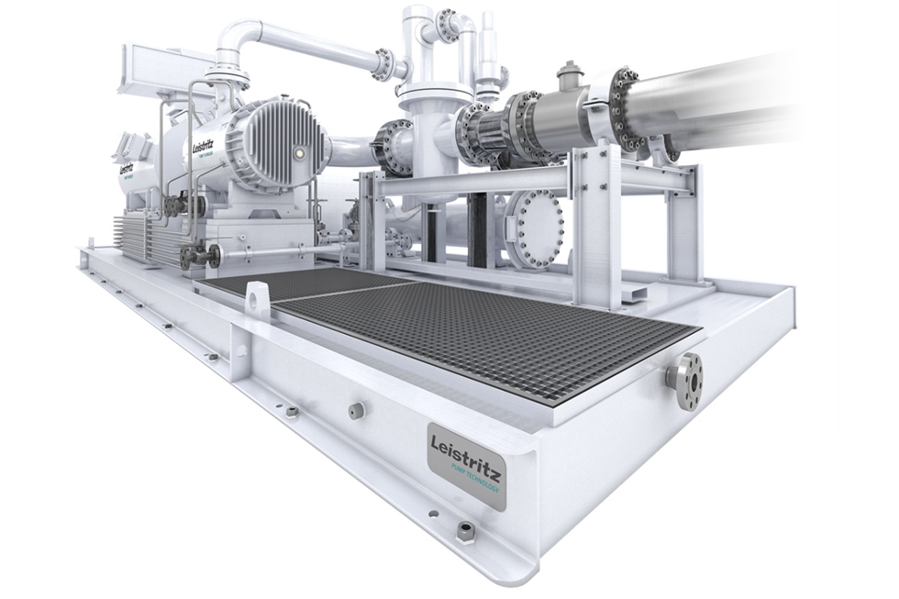
Example of a Hydro Compressor aggregate

Leistritz Pump Technology
Screw pump solutions and system provided by Leistritz Pump Technology are employed in the oil and gas, petrochemical, chemical industry, power generation and marine industries. Global engineering expertise and services are provided by a staff force of 300 working from headquarters in Nuremberg, Germany and locations in the USA, China, India, Singapore, Italy and the United Arab Emirates.

Press contact: More information:
Leistritz AG Leistritz Pumpen GmbH
Marija Perisic Roland Maurischat
Press and public relations Vice President Engineering Solutions
Markgrafenstraße 36-39 Markgrafenstraße 36-39
90459 Nuremberg/Germany 90459 Nuremberg/Germany
T: +49 (0) 911 4306 120 T: +49 (0) 911 4306 453
E: mperisic@leistritz.com E: rmaurischat@leistritz.com

