News release

Cooperating to save resources and energy

Nuremberg, 06. September 2022. At the K Show in Düsseldorf from October 19 - 26, Leistritz Extrusionstechnik GmbH will focus its presentation on its employees. Extrusion specialists will demonstrate their expertise in solving problems based on successfully concluded customer projects on the stage on the company’s booth. In addition, visitors will be able to learn about modern twin-screw extrusion technology & solutions for the recycling industry with intelligent control systems.

This year, on Booth F22 in Hall 16, Leistritz will show how the team has succeeded in developing customized solutions with its technical know-how, commitment and enthusiasm. In regular stage shows, the extrusion specialists will explain, with the aid of successful application examples, how the individual expertise of Leistritz helps to solve technically challenging tasks. Daniel Nagl, Managing Director of Leistritz Extrusion Technology, explains: "We don’t sell anything simply off the shelf. Every one of our machines is designed individually to fulfill the needs of our customer."

Successfully implemented projects
The chosen customer projects show how Leistritz combines technical know-how, organizational flexibility and consulting expertise in practice to the benefit of their customer, entirely in line with the company's motto for the trade fair, namely “Inspire – Innovate – Integrate”. The results of many years of experience are shown on the booth.

Biobased wine corks
The company Vinventions manufacturers closures for wine bottles. Plant based raw materials based on sugar cane are used in the innovative compounding with direct extrusion process. Leistritz has been cooperating with Vinventions since 1997. Together, the two companies have realized 15 installations.
The project combines sustainability, energy efficiency and a low CO₂ footprint, with outstanding product properties for high-quality wines. With its experience in compounding and the design of extruders, Leistritz has helped to integrate the fluctuating quality of plant-based raw materials into a stable process that ensures consistently high product quality. For further development, the customer made intensive use of the Leistritz technical center.
"Together with the customer, we worked intensively on process and thus product optimization in the technical center. This enabled us to provide the company with a high degree of flexibility without interfering with ongoing production," says Daniel Nagl.

Floorcoverings with PCR
The CLASSEN Group produces premium floorcoverings based on polypropylene under the brand name "CERAMIN". The recyclate quota is > 60 % in plastics content. The finished boards are free of PVC and can therefore be completely recycled in an environmentally friendly way at the end of their lifecycle. The high percentage of recycled material with varying material properties puts high demands on the process engineering.
Leistritz has, as a partner in the process development but also as a project partner in the development of a new manufacturing line, helped to produce the sustainable product more efficiently. The production output could be almost doubled from 5 t to 9 t per hour. For production of the flooring boards, Leistritz supplied two ZSE MAXX twin screw extruders and designed, built and started up the entire production facility. Together with the customer, the process was designed in such a way that only a minimum amount scrap is produced.

Christopher Helms is head of the technical center at Leistritz and was responsible for the project on the process engineering side. He explains: "The material combination for the coating is a completely new development by our customer. It is based on mineral materials and PP recyclate. As the use of recyclates in high-grade applications is becoming increasingly popular, we have optimized our plant and process technology to meet these needs.

We see the technology of our ZSE MAXX extruders as having a clear advantage in material recycling. The material is mixed homogeneously within a controlled low stress environment. Another plus point for recycling is the high degassing performance of the twin-screw extruders. In addition, the surface renewal, which is many times better than with single-screw extruders, allows efficient odor reduction and devolatilization of the melt."

Research for the circular economy
In a joint project with other companies, a research facility for the production of particularly resistant glass or carbon fiber-reinforced tapes has been realized. The LIT Factory at the JKU in Linz is simulating the optimal plastics cycle. It is a joint research project with other major companies.
"The process begins with our facility in the production of the base material for lightweight components, so-called unidirectional tapes. For this, we have developed a highly intelligent system. In the next stage of the process, lightweight components – for example for aircraft, sports equipment or wind turbines – are produced from these tapes. In the last step of the process, these lightweight parts are then recycled and used for the production of new tapes. With this project, the focus is above all on the aspect of lightweight construction and conserving resources, but it is also on digitization," explains Silvia Barthel, the designer responsible for the plant. Ms. Barthel is one of the experts who will present her project on the stage at the K in more detail.

Intelligent technology
A ZSE 60 iMAXX extruder with the latest control will be shown live on the booth. It is equipped with a synchronous motor from Kessler. According to the manufacturer's data, this is one of the most energy efficient converters currently available on the market. The gearbox is equipped with a condition monitoring system, in which intelligent sensors record the machine behavior and enable a rapid overview of the state of the equipment.

With the ZSE 60 iMAXX, another machine size has been added to the iMAXX model range. The series is known for its flexibility and modularity. It covers a wide range of applications in plastics extrusion and in recycling. Because of the high specific torque of up to 15.0 Nm/cm³ in combination with a high free volume (Da/Di = 1.66), the ZSE MAXX machines are among the world's most powerful co-rotating twin-screw extruders.

Illustration:
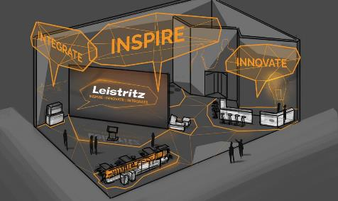
Picture caption: The stand at the Düsseldorf K fair is divided up into a zone for live presentations,
one for hands-on plant technology, and one with virtual facilities. Graphics: Leistritz Extrusionstechnik

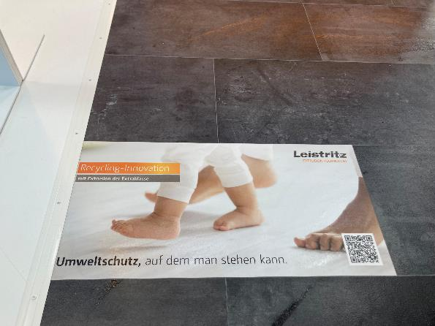

Picture caption: The flooring is robust, recyclable and free of plasticizers. Photo: Leistritz Extrusion Technology

About Leistritz Extrusionstechnik GmbH
For over 80 years now, Leistritz Extrusionstechnik GmbH, based in Nuremberg, has been building twin-screw extruders for processing technology. The Leistritz customers benefit from the company's know-how in various fields of material processing such as masterbatches, compounding, direct extrusion, laboratory extrusion and pharmaceutical extrusion. Worldwide, the company has around 250 employees and has three foreign branches – in the USA (American Leistritz Extruder Corp.), in China (Leistritz Machinery (Taicang) Co. Ltd.) and in Singapore (Leistritz SEA Pte. Ltd.), as well as a sales office in France and a network of global representatives.

For further information:
Leistritz Extrusionstechnik GmbH
Press and Public Relations
Daniela Franz
Markgrafenstraße 36-39
D-90459 Nürnberg
T: +49 (0) 911 4306 9623
E-Mail: dfranz@leistritz.com

