PRESS RELEASE 2/2020

AIMPLAS relies on Leistritz know-how to expand its capabilities

Spanish technology center has opened up a further application field: In order to perform pharmaceutical extrusion they decided for a Leistritz twin screw extruder.

Valencia (October 2020) – Since August a ZSE 18 HP-PH has been in operation inside a clean room ISO7/GMP at AIMPLAS, the Plastics Technology Center. With the versatile small extruder from German extrusion expert Leistritz Extrusionstechnik GmbH, the research and development facility is now taking the step towards pharmaceutical applications. "We have more than 30 pilot lines we develop or test various plastics applications with", says Raquel Llorens, Health Senior Researcher at AIMPLAS. "We want to expand our field of activity in the pharmaceutical (HME) and cosmetics industry, materials for bone and tissue regeneration and medical device developments among others.” AIMPLAS already has a Leistritz ZSE 27 MAXX pilot line, on which research and development in the field of reactive extrusion, recycling and other compounding applications are carried out.

Versatile and easy to scale-up
"We are very pleased that AIMPLAS decided for a Leistritz extruder", says Albrecht Huber, Product Area Manager Life Science & Pharma at Leistritz. “The ZSE 18 HP-PH is the perfect extruder for hot melt extrusion, wet granulation or filament extrusion – exactly the applications important to AIMPLAS. The line can be used for developing formulations as well as for producing small batches.” A decisive factor certainly was the fact that the machine geometry of all ZSE HP-PH extruder sizes (with screw diameters from 12 to 50 mm) are identical. Thus, scale-up from laboratory to production scale is easily accomplished, making customers tests transferable to larger production sizes.

Elaborate auxiliaries Leistritz is well diversified in the field of pharmaceutical extrusion: Depending on the requirements, the company offers various downstream equipment such as chill roll cooling or the Micro Pelletizer for cutting pellets down to 0.5 mm diameter. The process experts also excel

in inline process monitoring with the UvVis technology as PAT instrument (Process Analytical Technology). The AIMPLAS extrusion system, which also includes a side-feeder for conveying material downstream into the melt, is qualified in accordance with the latest GMP guidelines, including the control system.

Image (©AIMPLAS):

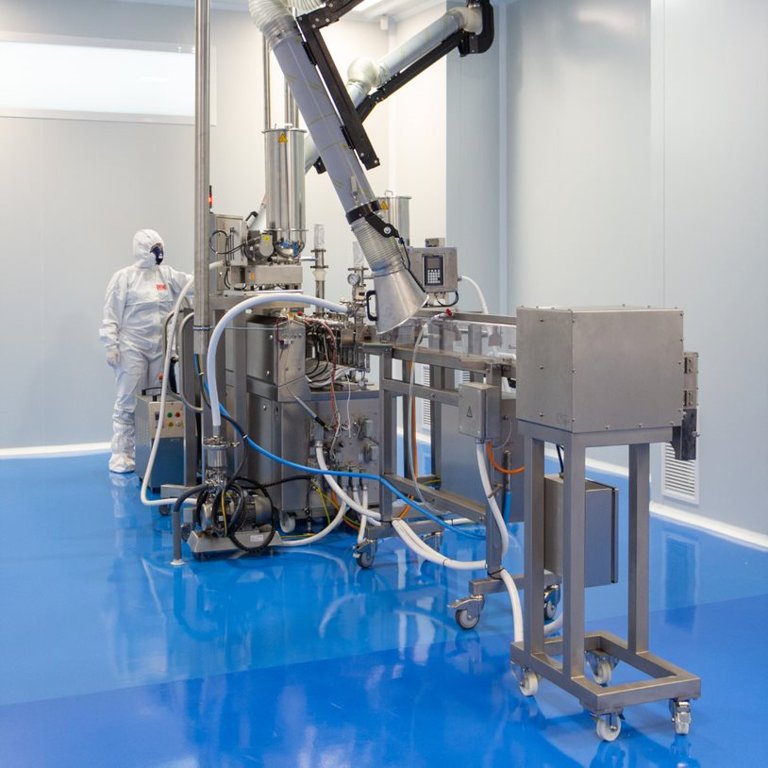

AIMPLAS clean room and Leistritz ZSE 18 HP-PH

Leistritz Extrusionstechnik GmbH
For more than 80 years, Leistritz Extrusionstechnik GmbH, headquartered in Nuremberg, has been manufacturing twin screws for compounding technology. Leistritz customers benefit from the know-how in various areas of material processing such as masterbatch, compounding, direct as well as laboratory extrusion, life science and pharmaceutical applications. The company employs about 200 people worldwide and has three branch offices: in the US (American Leistritz Extruder Corp.), in China (Leistritz Machinery (Taicang) Co. Ltd.) and in Singapore (Leistritz SEA Pte Ltd.), as well as a sales office in France.

About AIMPLAS
At AIMPLAS, the Plastics Technology Centre, our mission is twofold: to provide companies with added value so they can create wealth and to meet societal challenges to improve people’s quality of life and ensure environmental sustainability.
We also support the 17 SDGs of the UN Global Compact when carrying out our work and corporate social responsibility activities.

We are a non-profit research association and member of REDIT (Network of Technological Institutes of the Valencia Region) that offers companies in the plastics industry comprehensive, customized solutions, including development and innovation projects, training, and competitive and strategic intelligence, and technological services such as analysis, testing and technical assistance.

For more information:
Leistritz AG
Press and Public Relations
Marija Perisic
Markgrafenstraße 36-39
90459 Nuremberg
Phone: +49 (0) 911 4306 120

Email: mperisic@leistritz.com

AIMPLAS

Elisa Cones

Email: econes@aimplas.es

