PRESS RELEASE 3/2020

Recompounding with ZSE MAXX Extruder

German recycling specialist SYSPLAST uses state-of-the-art compounding plant from Leistritz
Extrusionstechnik GmbH.

Nuremberg (December 2020) – “On the one hand, it was the mature machine technology that made me go for a Leistritz extrusion line," SYSPLAST managing director Udo Dobberke sums up. “The decisive factor, however, was above all the process engineering advice and support I received from the entire team.” From February 2021, the Nuremberg-based recycling company will increase its annual production capacity of ABS regranulates on a new Leistritz plant by 4,800 tons. The heart of the new extrusion line will be a ZSE 60 MAXX twin screw extruder.

"Already some years ago, we started to strongly expand our activities in the recycling sector. This order is further proof of our competence in this segment," says Guido Kraschewski. He has been head of the Competence Center Recycling at Leistritz since mid-year. In his previous positions, he was responsible for sites and production at various recycling companies and therefore knows quite well what demands are put on staff, machines and materials today. "The recycling segment is constantly developing. Leistritz is strongly committed to this," says Kraschewski.

Regranulate in virgin material quality
"In terms of quality, our recompounds are in no way inferior to virgin material," says Udo Dobberke. "The basis for this is a high-quality machinery.” The recompounds are basically produced from pure and/or recycled plastics. In the future, ABS regranulate is to be produced on the new Leistritz ZSE MAXX plant.

ABS can be used in a variety of ways. The extrusion line is equipped with several dosing units and is partially automated. In the run-up to the project, tests were carried out in Leistritz' own technical center, ensuring an optimal conceptual design of the plant. This does not mean, however, that the new extrusion line will not also process other engineering plastics such as PC/ABS, polyamides or even polyolefins.

"Especially in the recycling sector, the ratio between quantity and quality must be appropriate," says Guido Kraschewski. A Leistritz ZSE MAXX extruder is ideally suited for this due to its OD/ID ratio of 1.66. The higher volume in the extruder results in less stress on the recycled material at constant speed. This is often reflected in better mechanical values, which, depending on the quality of the starting material, may allow to adjust the formulation in terms of costs.

Production will start at the beginning of next year. "We are very much looking forward to the start. SYSPLAST is a reference customer. We are happy to take anyone interested to visit the plant setup", says Guido Kraschewski.

Image (©Leistritz):

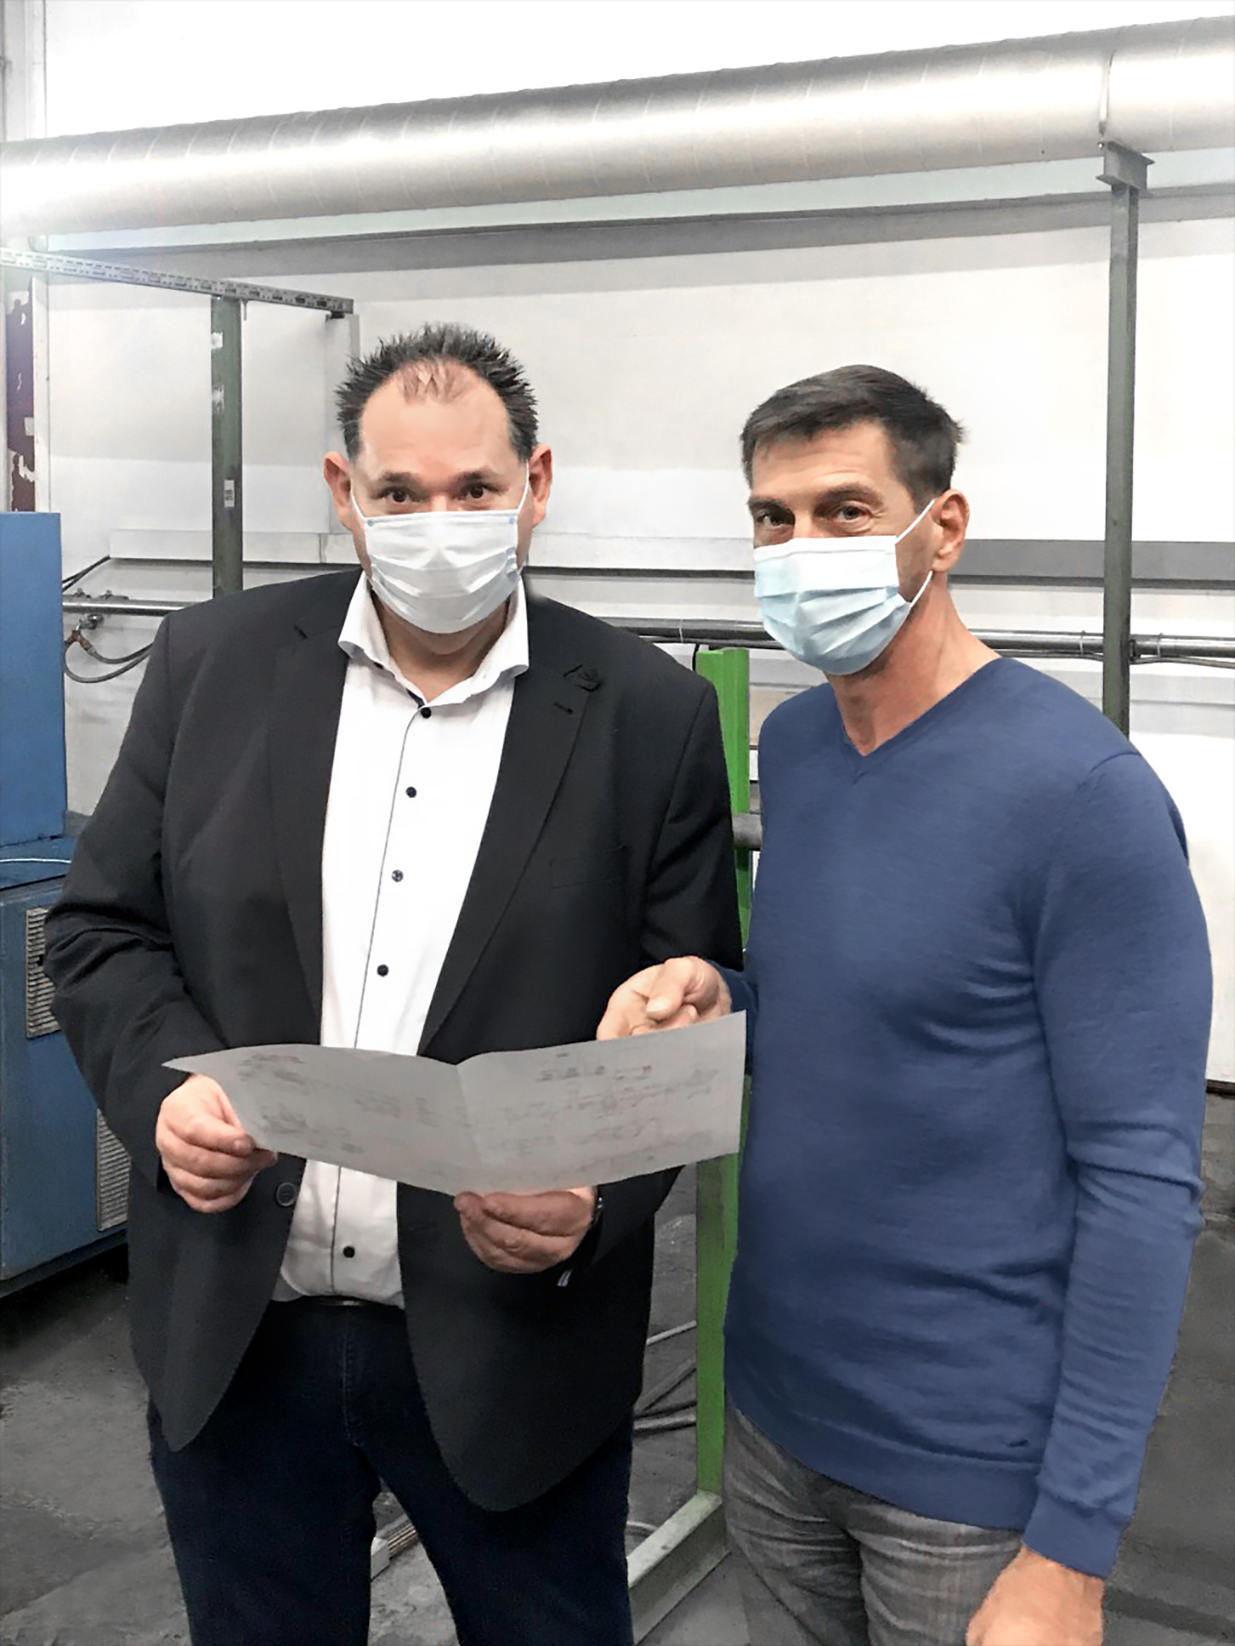
In spite of corona, consultations sometimes have to be done on site:
Guido Kraschewski (Leistritz) and Udo Dobberke (Sysplast)

Leistritz Extrusionstechnik GmbH
For more than 80 years, Leistritz Extrusionstechnik GmbH, headquartered in Nuremberg, has been manufacturing twin screws for compounding technology. Leistritz customers benefit from the know-how in various areas of material processing such as masterbatch, compounding, direct as well as laboratory extrusion, life science and pharmaceutical applications. The company employs about 200 people worldwide and has three branch offices: in the US (American Leistritz Extruder Corp.), in China (Leistritz Machinery (Taicang) Co. Ltd.) and in Singapore (Leistritz SEA Pte Ltd.), as well as a sales office in France.

SYSPLAST GmbH & Co. KG
In the 1990s, the former GRUNDIG AG, a global player in the consumer electronics sector, was one of the first European companies to take the important step of recovering plastics from the disposal of old appliances. After all, about 2,000,000 television sets and thus about 6,000 tons of plastics were produced annually. In order to reintroduce these plastics into its own production cycle, the company founded the "Center for Recycling Management" at its Nuremberg site, from which SYSPLAST GmbH & Co. KG was founded.

For more information:
Leistritz AG
Press and Public Relations
Marija Perisic
Markgrafenstraße 36-39
90459 Nuremberg
Phone: +49 (0) 911 4306 120

Email: mperisic@leistritz.com

