PRESS RELEASE 1/2019

Efficient machining duo for planetary roller screws:
End-to-end solution from Leistritz

Whether in robotics, machine tools or automation — due to their robust design, planetary roller screws constantly open up new fields of application and replace hydraulics. An efficient production of precision lead screws and nuts is ensured by a duo from Leistritz Produktionstechnik GmbH: the highly efficient LWN 120 IW internal whirling machine and the new LWN 160 HP. The highlight: Compared to grinding, these two increase productivity by a factor of 3 – 4 with uncompromising machining quality, while at the same time protecting the environment. At the EMO 2019 the LWN 160 HP is presented at the Leistritz stand E95 in hall 26.

Pleystein (September 2019) — In combination with servo motors from numerous fields, such as presses, dosing systems, robotics and automotive, planetary roller screws have become indispensable and are paving the way for new applications. The new technology is also increasingly being used in application areas of hydraulics and is thus supporting the trend toward further electrification of drive technology. “In order to be able to produce the high-precision lead screws and the orbiting thread rollers with the necessary dimensional accuracy and surface quality, until recently, there was no way around an elaborate, final grinding process for the hardened screws,” says Patrick Schuka, Head of Machine Tool Sales at Leistritz Produktionstechnik GmbH.
But this has come to an end now: The new LWN 160 HP (High Precision) hard whirling machine for external machining up to 6,000 mm in length increases productivity by a
factor of 3 compared to modern grinding machines, without compromising machining quality. On the contrary: The pitch accuracy of five-start threads is only 1 µm, the dimensional accuracy in the cylindricity of the thread diameter is better than 3 µm, and the roughness depth Ra achieved in the hard whirling process is less than 0.2 µm.
“The LWN 160 HP achieves this through the optimized whirling process, in which up to 90% of the heat is dissipated directly via the slant bed with the comma-shaped chips and, at the same time, no tensile stresses are induced in the workpiece,” explains Patrick
Schuka. During dry whirling, no stresses are induced in the material, which in turn ensures an extremely long service life of the screws. The lead screws for planetary roller screws or ball screws manufactured on this machine ensure maximum smoothness during their subsequent use.

Manufacturing long nuts without loss of quality
In classic turning and grinding processes, nuts can only be manufactured in a length ratio of 3 - 4x the diameter. This is due to the poor stability of the tool, which decreases with increasing bore length and at a constant diameter. This is different with internal whirling on the LWN 120 IW: As the tool is supported in the bore at large L/D ratios, it is easy to produce internal threads that are up to 20x as long as the diameter. With a bore diameter of 20 mm, internal threads with a length of 400 mm can thus be manufactured without loss of quality. With this ability to produce internal threads of theoretically unlimited length, the LWN 120 IW is also ideal for the machining of inverted planetary roller screws with long internal threads. This allows the range of applications of the planetary roller screws to be further increased. “Especially in the machining of stainless steels or steels for aviation, the whirling duo shows its strength compared to conventional processes,” adds Patrick Schuka.

Sustainable production
The hard whirling machines LWN 160 HP for external machining and LWN 120 IW for internal machining are not only champions in terms of productivity, high profile and pitch accuracy, as well as the surface quality of the ball and lead screws manufactured on them. They also impress with regard to sustainability.
A benefit for the environment lies in the machining process: Leistritz' patented whirling process is able to process solid material up to a Rockwell hardness of 64 HRC completely without cooling lubricants, i.e. dry. Consequently, the subsequent cleaning of the chips and the preparation and disposal of cooling emulsion and detergents are also eliminated. This not only significantly saves resources, but also reduces the impact on the environment and is kind to your wallet.
Additionally, due to the shorter machining time by a factor of 3 compared to grinding, not only valuable machining time is reduced. A lot of energy is saved as well, which ultimately has a positive impact on the environmental footprint of customers who are increasingly looking for machines and processes for sustainable production.

Leistritz Produktionstechnik GmbH at the EMO 2019:
Machine tools in hall 26/stand E95; Tools in hall 4/stand B31
Images: ©Leistritz

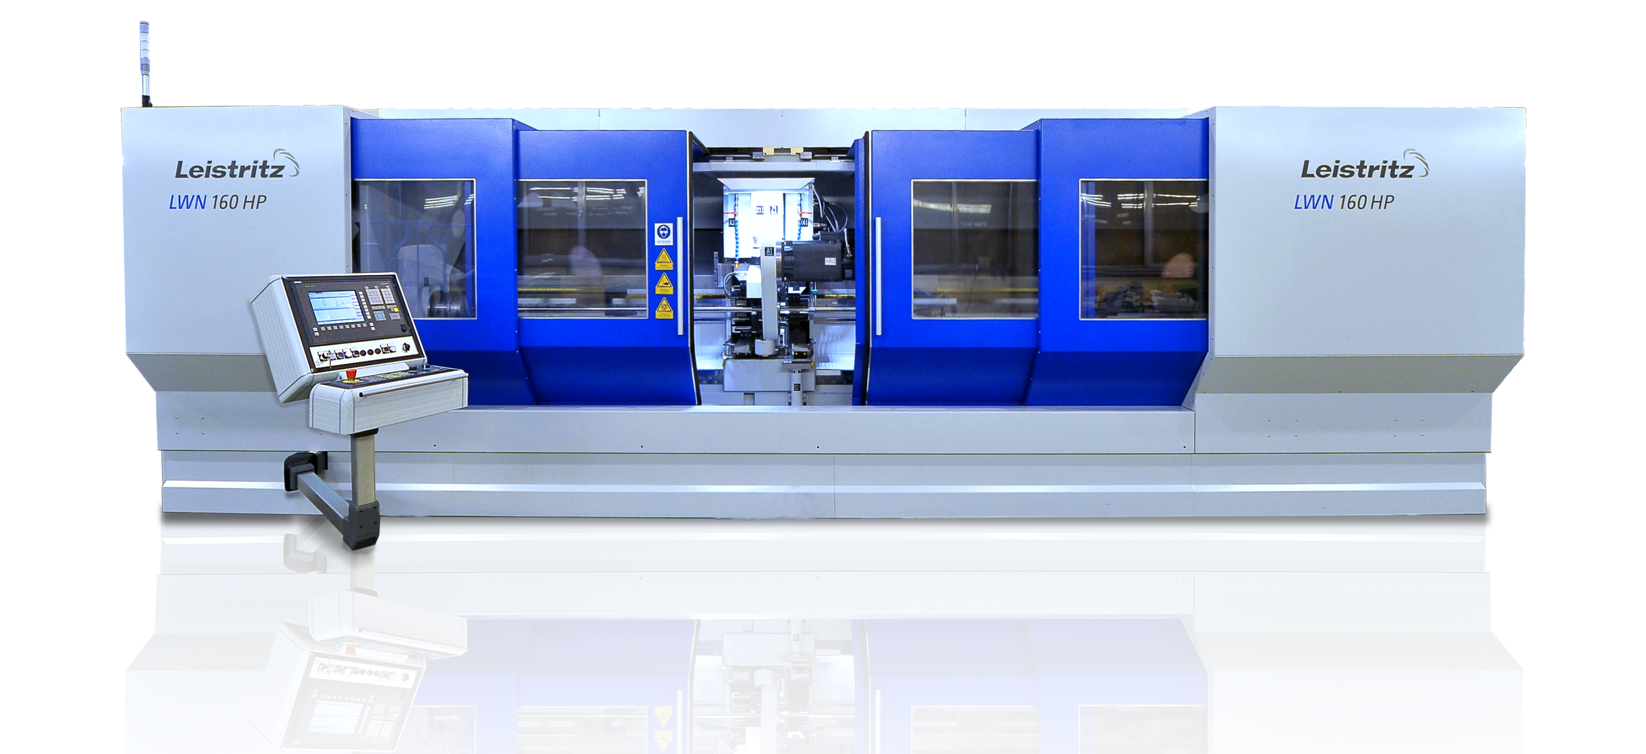
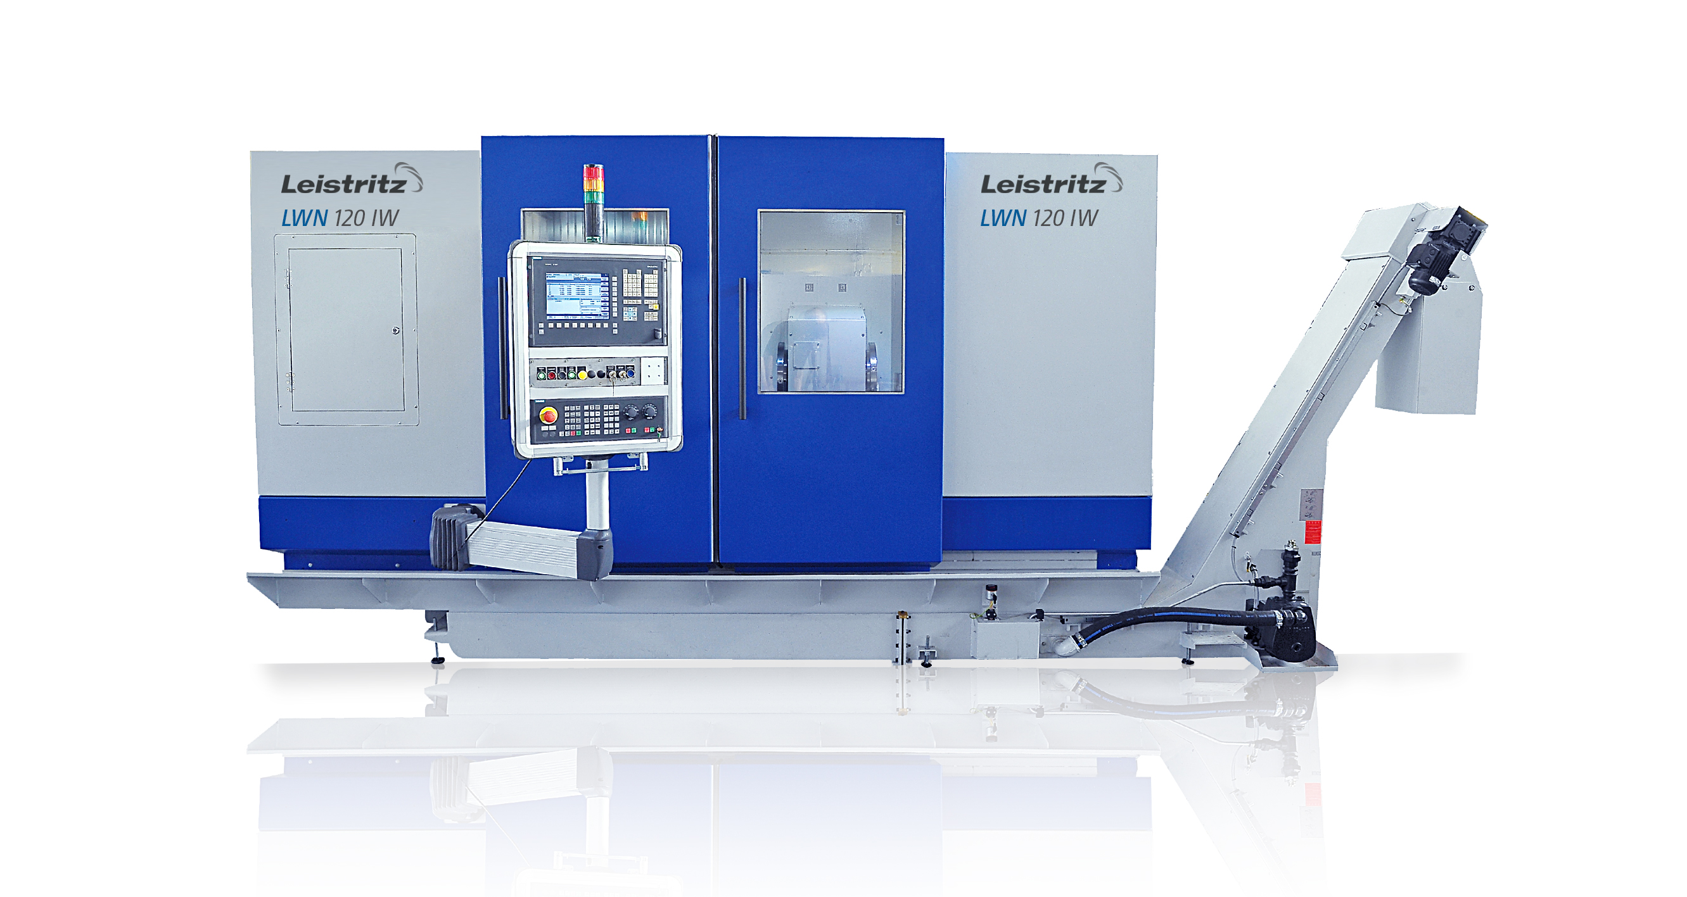

LWN 160 HP and LWN 120 IW: Strong duo for efficient machining of high-precision planetary roller screws

Leistritz Produktionstechnik GmbH
As part of the Leistritz Group, Leistritz Produktionstechnik GmbH, headquartered in Pleystein, offers solutions for the economical production of whirling machines, keyseating machines and carbide tools. Leistritz is a partner of the automotive and aerospace industries, the oil and gas industry, drive technology and insert and die making. Utilizing synergies from two different competencies – machine tools and tools – the company has developed a wealth of knowledge. The experience gained in both areas helps the company to continuously develop its technology and thus supply machines and tool solutions of the highest quality from a single source. The core competence lies in the development and production of customer-specific solutions and processes.

For more information:
Leistritz AG Leistritz Produktionstechnik GmbH
Press and Public Relations Head of Machine Tool Sales
Marija Perisic Patrick Schuka
Markgrafenstraße 36-39 Leistritzstr. 1 - 11
90459 Nuremberg/Germany 92714 Pleystein/Germany
Phone: + 49 (0) 911 4306-120 Phone: +49 (0) 9654 89-403
Email: mperisic@leistritz.com Email: pschuka@leistritz.com

