PRESS RELEASE 2/2019

Machining innovation: Highest precision and
efficiency with new multi-function tool

The precise machining of thin work pieces 1.5 mm diameter onwards is not efficiently possible with conventional machining tools. At the EMO 2019 Leistritz presents a new multi-function tool that solves the problem: Up to 6 times faster than classical machining, with the Over-Cut+ you can machine two different diameters and the finishing of the work piece ends in just one work step.

Pleystein (September 2019) – “You cannot outwit physics even in machining”, notes Dr. Michael Wengler, director at Leistritz Produktionstechnik GmbH. “If a very thin and long rod with say 4 mm diameter is to be overtwisted at 100 mm length for an end dimension of 1.5 mm, then the tool will radially displace the rotating work piece.” The result: Instead of a cylindrical work piece with 1.5 mm diameter, you get a conical one. The supporting sleeve in the tailstock is usually not suitable for such thin diameters or require several more work steps to go from larger diameters until final polishing. “We have found a revolutionary solution which we would like to present at this year’s EMO for the public,” says the tools’ specialist. “The innovative machining system Over-Cut+.”
The multi-cut basic system of Over-Cut has already been successfully introduced a year before. The new Over-Cut+ is the subsequent further development of the multi-function tool. Firstly, it now allows the multi-level finishing with two different diameters as well as the integration of the work piece-end polishing in one work step. The resulting increase in efficiently is impressive. The Over-Cut+ can machine and finish up to six work pieces in one tool holder with the highest precision in the same time it takes to conventionally machine a work piece with two diameters.

But this is not all, adds design manager Bernhard Vater: “You can also get the different diameters with the highest surface quality with the replaceable cutting inserts of our Over-Cut+. This saves additional costs and further increases the efficiency of the system.”
Design details Over-Cut+
The two-part Over-Cut+ tool consists of one round basic holder with a head diameter of 24 to 40 mm, which is fabricated with individual shaft designs at client request, and a replaceable round solid-carbide insert with inside cutting edge with diameters from 12 to 32 mm. The carbide tool insert is adjusted for cutting and drilling as per the respective machining diameters. Two of these inserts with different machining diameters are securely clamped in the basic holder using three screws at definite distances. An additional safety pin for each tool insert here ensures a rotation lock. Three screws arranged at a 120 degree angle placed in each Over-Cut+ insert allow fine adjustment for a perfect round cut.
Several chip space openings in this innovative tool head help in reliably removing the chips. The optional inner coolant supply through the shaft removes the chips and lengthens the service life of the tool inserts to a maximum.
Looking into the future, Bernhard Vater is happy about the client demands: “With the Over-Cut+, we now offer the most efficient tooling system for the final polishing of work pieces with smaller diameters. As per the requirements of our clients, we will continue to further optimize this innovative system in the future to meet these requirements.”

Leistritz Produktionstechnik GmbH at the EMO 2019:
Tools in hall 4/stand B31; machine tools in hall 26/stand E95

Photo: ©Leistritz

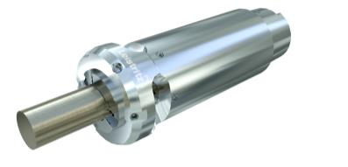

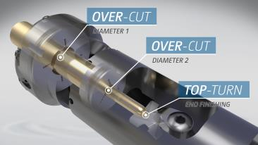

Over-Cut+ tools - have no competition when it comes to machining elongated work pieces of 1.5 mm onwards

Leistritz Produktionstechnik GmbH
As part of the Leistritz Group, Leistritz Produktionstechnik GmbH, based in Pleystein, Germany, offers solutions for economic production of whirling machines, keyseating machines and carbide tools. Leistritz is a partner to the automotive, aviation and aerospace industry, the oil and gas industry as well as the drive technology and the die and mould industry. By exploiting synergies from two different areas of expertise, machine tools and tools, the company has been able to build up a wealth of knowledge. The experience gained in both fields helps the company to continuously develop its technology and thus offer high-quality machine and tooling solutions from a single source. The company's core skills lie in the development and production of customized solutions and processes.

For more information:
Leistritz AG Leistritz Produktionstechnik GmbH
Press and public relations General Manager
Marija Perisic Dr. Michael Wengler
Markgrafenstraße 36-39 Leistritzstr. 1 - 11
90459 Nuremberg/Germany 92714 Pleystein/Germany
Phone: + 49 (0) 911 4306-120 Phone: +49 (0) 9654 89-805
Email: mperisic@leistritz.com Email: mwengler@leistritz.com

