PRESS RELEASE 1/2019

Full scope partner from development to ready-to-install components
Leistritz Turbinentechnik GmbH presents its extensive product portfolio at the Paris Air Show from 17 to 23 June 2019.

Paris (June 2019) – "Inspired by Nature" is the motto German-based Leistritz Turbinentechnik GmbH uses to present its manufacturing competence in the field of engine components for aviation. “These highly sensitive parts must meet the most stringent requirements“, Dr. Mathias Klein, managing director at Leistritz Turbinentechnik GmbH explains this year’s participation of the company. “The production of complex geometries of the highest precision is crucial in order to deliver perfect results. Similar to nature, which creates accurate strategies and shapes, we strive to fully meet the high expectations of our customers.“ As one of the few companies that unites various manufacturing processes from forging to finishing under one roof, Leistritz covers the entire value chain as a full scope supplier - from the raw part to the ready-to-install component.

This year Leistritz demonstrates the production of complex blade designs and the use of critical materials, among other things with the exhibited blisks. In the fan area, the team presents a patented process that combines forming technology with additive and subtractive processes and due to its scalability is suitable for the production of metal leading edges to protect carbon fiber blades. The innovative approach provides flexibility in selecting materials and cost advantages. Dimensional accuracy in narrow tolerance ranges and perfect surfaces are characteristic of state-of-the-art blade geometries produced on a new generation of ECM machines developed in-house: PECM (Pulsed ElectroChemical Machining) machines.

"How can we respond to the constantly growing demand for lighter components, but at the same time make production more uncomplicated? We have been working on these questions for years", says Dr. Klein. “The answer is additive manufacturing! There is an enormous potential here, also in the combination with the rather traditional processes.“ At the trade fair
Leistritz will show additive manufactured parts, which have been developed in cooperation with partners.

Leistritz Turbinentechnik GmbH at the Paris Air Show in hall 2C/stand B318

Images (©Leistritz):

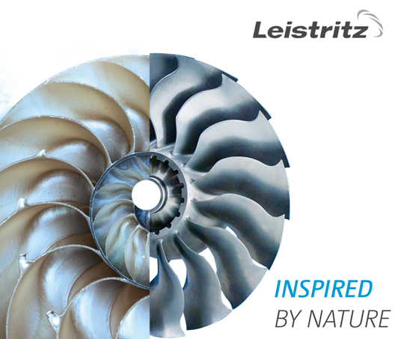

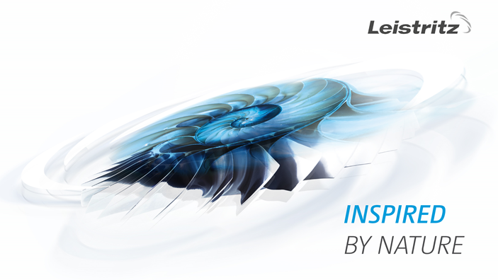

The production of complex geometries of the highest precision is crucial in order to deliver perfect results – just like in nature.

Leistritz Turbinentechnik GmbH
For almost 115 years Leistritz Turbinentechnik GmbH has been supplying partners from the aviation and energy sectors with engine and turbine components. Leistritz customers profit from the company's long history of experience and technological leadership, and from its almost 1000-strong workforce employed worldwide. At its headquarters in Remscheid, at its plant in Nuremberg and at its subsidiary branches in Thailand and Croatia all the important production technologies are offered: precision forming, CNC milling and grinding, conventional and isothermal forging and electrochemical processing.

Contact
Leistritz Turbinentechnik GmbH
Tanja Müller
Lempstr. 24
42857 Remscheid
T: +49 (0)2191 6940-226
Email: tmueller@leistritz.com

