PRESS RELEASE 1/2019

Inspiring ZSE iMAXX twin screws

From October 16 to 23, 2019, Leistritz Extrusionstechnik GmbH will be presenting

the next generation of its extruder series ZSE iMAXX at the K 2019 trade fair

(Hall 16 / Stand F22).

Düsseldorf (October 16, 2019) — “With our ZSE iMAXX series we are demonstrating how to make the extrusion process even more efficient and flexible. This provides a lot of fresh inspirations, matching the trade fair slogan 'inspiring XXtrusion',“ explain Sven Wolf Anton Fürst, Managing Directors of Leistritz Extrusionstechnik GmbH. “For this purpose, we have further developed our ZSE iMAXX twin-screw extruders in terms of both machine technology and process engineering.“

The result is an extruder series that not only impresses with a new functional, modern design, but also opens up completely new dimensions in regard to flexibility and handling. “With various equipment packages, we give system operators the opportunity to extend the comprehensive basic configuration of their extruder even more,” says Fürst. Five packages are available: Sensor Technology, Optics, Performance, Efficiency and Service. The ZSE iMAXX series includes machines with screw diameters of 18, 27, 35, 40, 50 and 60 mm.

“We're going to show what the whole thing looks like in practice with a ZSE 27 iMAXX at our stand,” says Wolf. “With this machine, we have put together the whole package of possibilities and built in many features to make production even more efficient.” But not only that: The twin-screw extruder is also at the heart of a Circular Economy Extrusion Line — a recycling process that demonstrates live the gentle processing of an HFFR compound.

Improved product design
The new exterior of the ZSE iMAXX extruder is striking at the very first glance: a continuous, closed cover. “Not only the processing unit, but also the side feeder is covered,” says Wolf. “So far, this is unique.” In this way, the entire process is protected from contact and contamination and is easy to clean. Particularly in areas such as masterbatch production, where frequent product changes result in an increased cleaning effort, the end-user benefits from considerable time savings and reduced downtime.

Other highlights that guarantee an easier handling include the integration of the temperature control unit in the machine frame. Generally, all replaceable units are positioned in a way that guarantees optimum accessibility. This makes the cleaning and replacement of individual components extremely easy. “The LSA die head, which is particularly effective in masterbatch applications, also ensures a quick change-over,” explains Fürst. This die head has only two screw connections and can be opened easily and safely in a few simple steps. A quick cleaning during color change is ensured by the removable screen and die.

Increased energy efficiency
“The major issues of our time are, among other things, resource conservation and the efficient use of energy. Especially as a machine manufacturer, we are steadily working to consequently align our technologies with this,” says Wolf. “The environmental idea goes hand in hand with the reduction of energy costs. After all, this factor is not to be neglected in a 24/7 production.” For this reason, the ZSE iMAXX extruder uses a synchronous motor, which impresses with its high efficiency. High energy efficiency is also ensured by the possibility of completely insulating the processing unit in order to reduce radiation losses.

Another feature is the torque measurement, which is optionally available for extruders of size 35 and larger. Wolf explains: “Especially with new formulations, important insights can be gained with regard to energy input.” The closed dual-circuit temperature control system, which is installed in the base frame together with the coax valves, meets the needs of a lower water consumption. Thanks to the resin cartridge, which is installed as standard, the supplied water, too, is optimally treated for process application. Calcification and contamination is thus minimized.
Comprehensive monitoring
“In the course of the continuous further developments in process technology, we have paid special attention to intelligent process monitoring, particularly in the field of Industry 4.0,” says Wolf. “On-line process and quality control has increasingly become an indispensable asset in the extrusion process.” The optionally available Leistritz elongational rheometer, which has a patented die geometry, enables the on-line measurement of the shear viscosity with shear rates in the range of 10 to 10,000 s⁻¹, and of the elongational viscosity with elongation rates between 5 and 75 s⁻¹. During the extrusion process, a small amount of the melt flow is channeled off via a bypass system and pushed through the rheometer's slot die. After the measurement, the material is transferred back into the process without losing any material. The measurement results can be visualized on the extruder control unit.

Smart sensor technology
“The gearbox is a critical component of the extrusion line. A failure can shut down a production for several weeks — and that costs time and money. That's why we offer solutions here as well, to prevent emergencies,” knows Fürst. An oil sensor can be installed to measure the condition of the gear oil. It continuously measures oil-specific values and will display a message if the values exceed or fall below predefined limits. “In general, there are rigid intervals for oil change. By installing a sensor, these intervals can be significantly extended,” explains Sven Wolf. There are four other sensors that belong to the LOVM (Leistritz On-line Vibration Measurement). They continuously monitor the condition of the gears and bearings in the gearbox and report any emerging failures.

“The i in ZSE iMAXX has always stood for intelligent and integrated solutions. At this trade fair, we're now adding the term 'inspiring'. That's exactly our approach with the ZSE iMAXX basic variant and the different equipment packages," explains Sven Wolf. “We are pleased to provide sophisticated solutions that offer real added value to end-users.“

Information about ZSE MAXX
Due to the high specific torque (up to 15.0 nm/cm³), the ZSE MAXX machines are among the world's most powerful co-rotating twin-screw extruders. Added to this is the high volume in the screw (OD/ID = 1.66). They provide a very good homogenization performance at a relatively low energy input.

Leistritz Extrusionstechnik GmbH at the K trade fair in Hall 16 / Stand F22

Photo (© Leistritz):
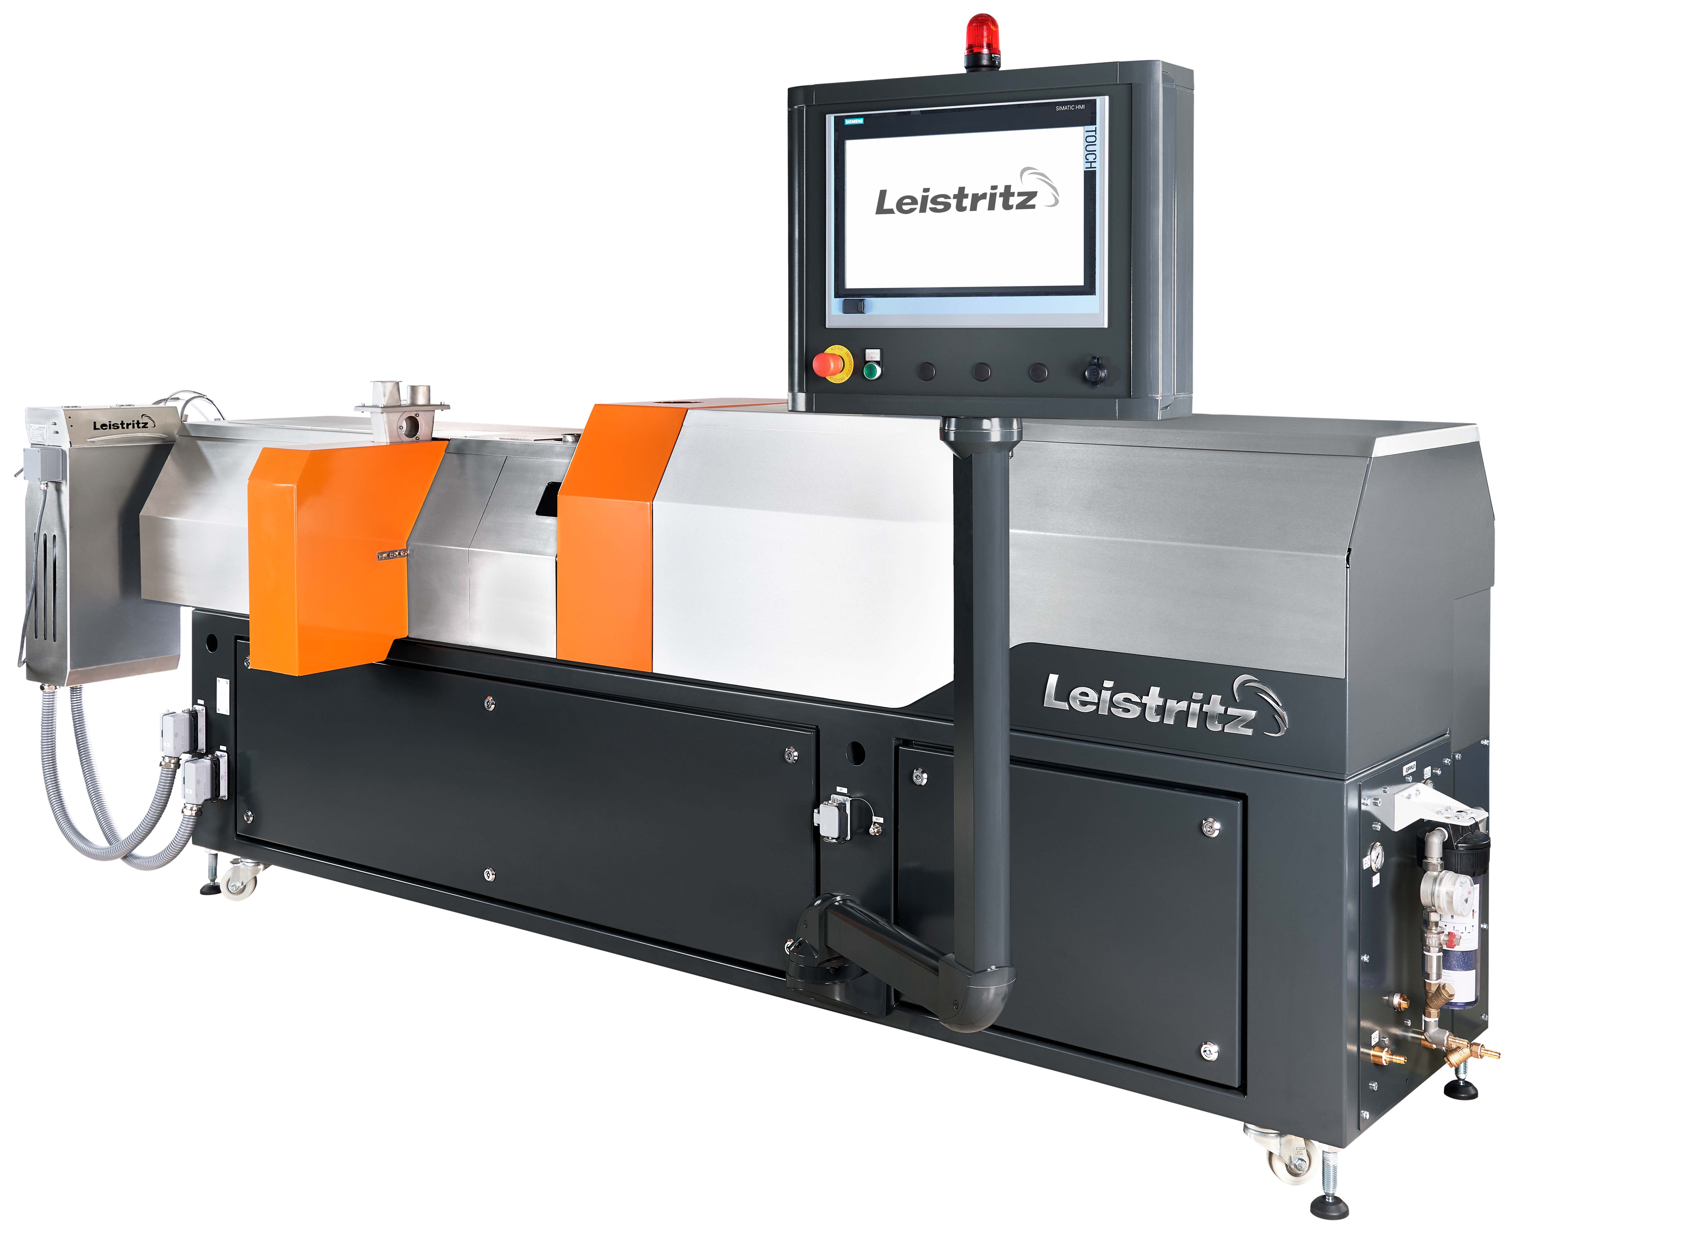
Sophisticated design, maximum flexibility, perfect process monitoring — the ZSE iMAXX extruder

The press release and image are available for download in the press section of the
Leistritz website.

Leistritz Extrusionstechnik GmbH
For more than 80 years, Leistritz Extrusionstechnik GmbH, headquartered in Nuremberg, has been manufacturing twin screws for compounding technology. Leistritz customers benefit from the know-how in various areas of material processing such as masterbatch, compounding, direct extrusion as well as laboratory and pharmaceutical extrusion. The company employs about 190 people worldwide and has three branch offices: in the US (American Leistritz Extruder Corp.), in China (Leistritz Machinery (Taicang) Co. Ltd.) and in Singapore (Leistritz SEA Pte Ltd.), as well as sales offices in Italy and France.

For more information:
Leistritz AG
Press and Public Relations
Marija Perisic
Margrafenstraße 36-39
D-90459 Nuremberg
Phone: +49 (0) 911 4306 120
Email: mperisic@leistritz.com

