PRESS RELEASE 1/2020

rPET - Sustainable packaging!

It is fully recyclable: foamed, recycled PET (rPET) is the innovative alternative to beverage cartons. The production of this high quality foam film is based on a production line with a Leistritz twin-screw extruder. Leistritz Extrusionstechnik GmbH demonstrates its engineering competence in this field at the Interplastica 2020 in hall 2.2, stand 22 C38.

Moscow (Jan. 28, 2020) – The recycling of beverage packaging poses a great challenge to the industry: the layers of the film mixture cannot be separated properly from each other. Recycling is therefore very difficult. "The solution is foamed rPET which we will show at the Interplastica", knows Sven Wolf, managing director at Leistritz Extrusionstechnik GmbH. The plant technology, which was developed and tested together with partners, facilitates the extrusion of rPET pellets into high-quality foamed films. Besides Leistritz, recycling specialist NGR and film producer Kuhne are involved in this trend-setting development project. "We have already proven our competence as a system supplier very successfully in numerous projects. We are very pleased to be able to contribute our innovative strength to this extraordinary venture," says Wolf.

The idea of using rPET for beverage cartons comes from ForPET, an innovative Russian company. One of the owners, Sergey Nikitenko explains: "Our goal was to produce a material that allows recycling without limits. We succeeded in this and have since patented it worldwide". The film is a 100 % recyclable alternative to conventional composite materials.

Designed for recyclability
A beverage packaging must be quite light, but still very robust. It should ensure a long shelf life and protection of the contents. Different materials are combined to form a composite to ensure that all the required properties are met. In addition to paper, for example, several layers of polyethylene are used. In order to be able to store the contents without preservatives for a longer period without cooling, an aluminum film layer is incorporated as a gas barrier. However, it is precisely this film mixture that poses special challenges to the technology: Since the layers cannot be cleanly separated from each other in the recycling process, it is difficult to use the recycled material to manufacture new products. With foamed rPET, the situation is different. The development towards monomaterial packaging and thus the design for recyclability is taken into account. On the one hand, PET as a raw material can largely cover all the functions of packaging with just one material; on the other hand, the separation of additional barrier layers (e.g. aluminum, if required) in the melt process can be solved very efficiently and economically.

An economical and ecological solution: foamed rPET
Several process steps are necessary for the production of a foamed rPET film: The preparation of the rPET flakes with appropriate additives is carried out in a Leistritz twin-screw extruder. In combination with an LSP reactor (Liquid State Polycondensation) from NGR, a tailor-made pellet or melt for downstream foaming is produced. The loading of the melt with a physical blowing agent is also performed in a Leistritz twin-screw extruder after which it reaches Kuhne's film extrusion downstream. This is where the foam film is produced, which can be further processed and is fully recyclable.

„We are currently working with investors to establish a commercial development center in Russia,“ Nikitenko explains the next steps. The final development is expected to be completed by the end of 2020. After that, the first commercial products will find their way into the market. „The great interest shows how popular this topic is. International brands, such as a leading global beverage manufacturer, as well as institutional investors have already shown great interest on the occasion of the first design presentation of the product at our stand at K 2019," Wolf is pleased to report. "The response at the Interplastica will certainly be just as enthusiastic".

Leistritz Extrusionstechnik GmbH at the Interplastica 2020 in hall 2.2, stand 22 C38.

Image:

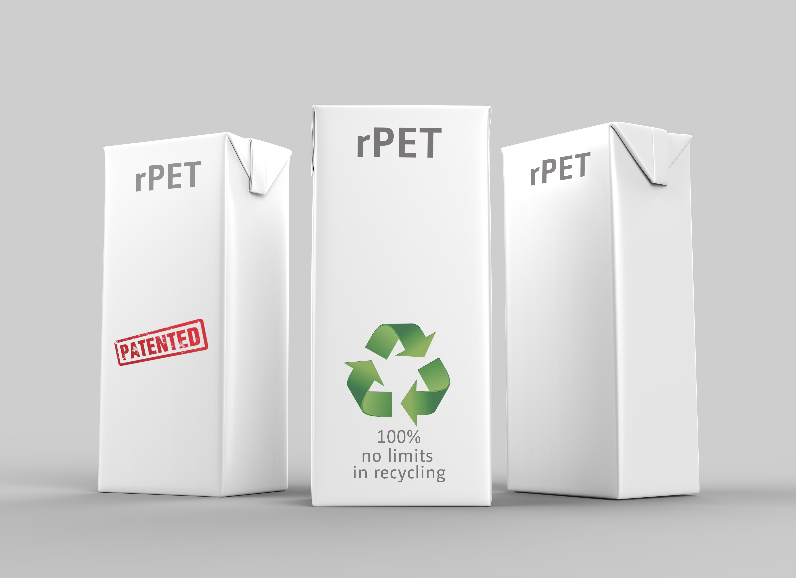
Foamed rPET is THE alternative to conventional beverage packaging.

Leistritz Extrusionstechnik GmbH
For more than 80 years, Leistritz Extrusionstechnik GmbH, headquartered in Nuremberg, has been manufacturing twin screws for compounding technology. Leistritz customers benefit from the know-how in various areas of material processing such as masterbatch, compounding, direct extrusion as well as laboratory and pharmaceutical extrusion. The company employs about 190 people worldwide and has three branch offices: in the US (American Leistritz Extruder Corp.), in China (Leistritz Machinery (Taicang) Co. Ltd.) and in Singapore (Leistritz SEA Pte Ltd.), as well as sales offices in Italy and France.

For more information:
Leistritz AG
Press and Public Relations
Marija Perisic
Margrafenstraße 36-39
90459 Nuremberg
Phone: +49 (0) 911 4306 120

Email: mperisic@leistritz.com

